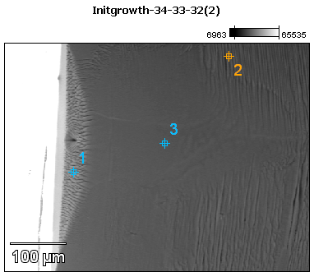

Image Name: Initgrowth-34-33-32(2)

Image Resolution: 512 by 384

Image Pixel Size: 1.08 µm

Acc. Voltage: 12.0 kV

Magnification: 230

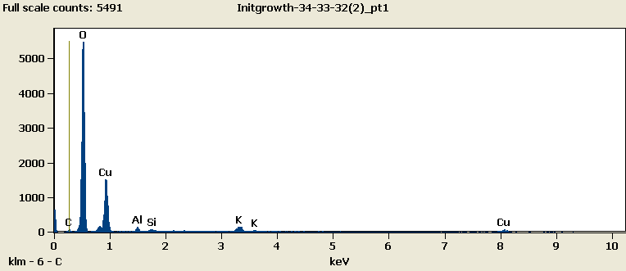

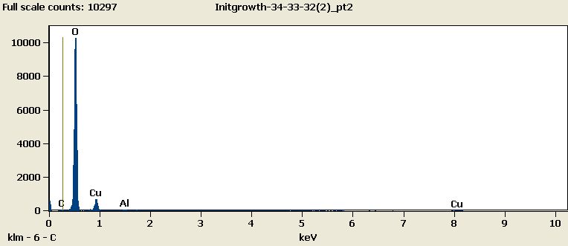

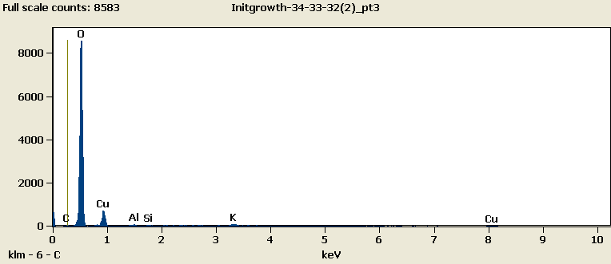

Weight %

|  |  |  |  |  |  |  |
| --- | --- | --- | --- | --- | --- | --- |
|  | ***C-K*** | ***O-K*** | ***Al-K*** | ***Si-K*** | ***K-K*** | ***Cu-L*** |
| ***Initgrowth-34-33-32(2)_pt1*** | 1.43 | 54.30 | 0.95 | 0.67 | 3.42 | 39.22 |
| ***Initgrowth-34-33-32(2)_pt2*** | 0.88 | 76.21 | 0.52 |  |  | 22.39 |
| ***Initgrowth-34-33-32(2)_pt3*** | 0.30 | 73.61 | 0.54 | 0.33 | 1.91 | 23.32 |

Weight % Error (+/- 1 Sigma)

|  |  |  |  |  |  |  |
| --- | --- | --- | --- | --- | --- | --- |
|  | ***C-K*** | ***O-K*** | ***Al-K*** | ***Si-K*** | ***K-K*** | ***Cu-L*** |
| ***Initgrowth-34-33-32(2)_pt1*** | ±0.15 | ±0.30 | ±0.09 | ±0.05 | ±0.11 | ±0.44 |
| ***Initgrowth-34-33-32(2)_pt2*** | ±0.14 | ±0.32 | ±0.05 |  |  | ±0.38 |
| ***Initgrowth-34-33-32(2)_pt3*** | ±0.13 | ±0.33 | ±0.05 | ±0.05 | ±0.22 | ±0.39 |

# Cations

|  |  |  |  |  |  |  |
| --- | --- | --- | --- | --- | --- | --- |
|  | ***C-K*** | ***O-K*** | ***Al-K*** | ***Si-K*** | ***K-K*** | ***Cu-L*** |
| ***Initgrowth-34-33-32(2)_pt1*** | 0.00 | 0.00 | 0.00 | 0.00 | 0.00 | 0.00 |
| ***Initgrowth-34-33-32(2)_pt2*** | 0.00 | 0.00 | 0.00 |  |  | 0.00 |
| ***Initgrowth-34-33-32(2)_pt3*** | 0.00 | 0.00 | 0.00 | 0.00 | 0.00 | 0.00 |